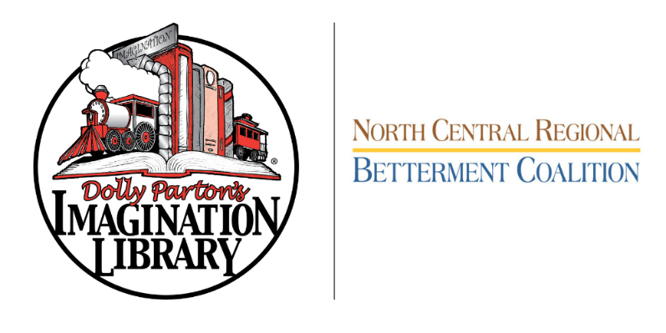
Child Information
1st Child’s FULL Name________________________________________________________
Child’s Date of Birth_______________________________
2nd Child’s FULL Name_______________________________________________________
Child’s Date of Birth_______________________________
Child’s Mailing Address______________________________________________________
City_________________________________ State_________ Zip_____________________
Caretaker Information
Authorized Adult Name______________________________________________________
Phone____________________________ Email ____________________________________

“I hereby explicitly consent to allow the Dollywood Foundation, Inc. to use the information provided herein for the purposes of participating
in Dolly Parton’s Imagination Library book gifting program. To measure the benefits of this program we may create datasets with the
information provided herein and share them with research and educational advancement partners. You agree to review our full Terms &
Conditions and Privacy Policy by visiting imaginationlibrary.com. By signing and submitting this form you expressly consent to the terms
set forth herein.”

Authorized Adult Signature___________________________________________________

ENROLL YOUR CHILD TODAY!
Simply fill out the form above and mail to: NCRBC POB 142 LaSalle, IL 61301
Or email to DPIL@ncrbc.net www.ncrbc.net
Office Use Only

Date Received_________________________ Notes______________________________________

